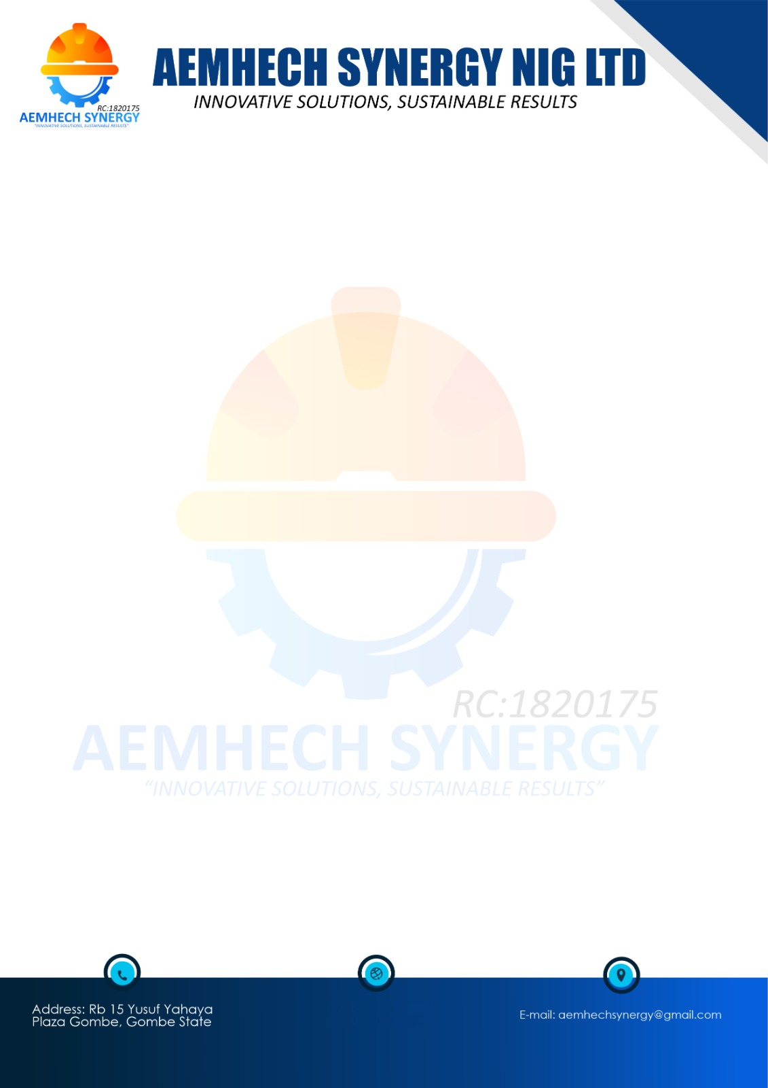
OFFER LETTER
29/05/2026
MUKTAR IBRAHIM
KOFAR FADA AZARE
Dear Sir/Ma,
OFFER LETTER FOR THE PURCHASE OF HOUSING UNIT AT JIBI VILLAGE, DEI DEI ROAD, KUBWA EXPRESS, ABUJA/NIGER STATE

Sequel to your interest in our Estate, we are pleased to offer you one Housing Unit of Executive 1 Bedroom Semi-detached flat at JIBI VILLAGE, DEI DEI ROAD, KUBWA EXPRESS, ABUJA/NIGER STATE. The details of the offer are as follows:
Description: 1 Unit of Executive 1 Bedroom Semi-detached flat
Type of Use: Strictly Residential
Purchase Price: ₦770,033.62 (SEVEN HUNDRED SEVENTY THOUSAND, THIRTY-THREE NAIRA AND SIXTY-TWO KOBO) ONLY
Please note that this purchase price is valid for 3 calendar months and may be subject to review thereafter.

TERMS AND CONDITIONS OF OFFER
- You shall be bound by the terms and conditions for sale of the property as agreed by our company (AEMHECH SYNERGY NIG LTD).
- Your duration for the acceptance of this offer is 2 weeks from the date of receipt of this letter.
- This letter of offer is not transferable and not to be sold.
- The title Deed to the property will be transferred to you upon full payment for the value of the property.
- You must take possession of the property within 3 Months after Allocation.
- This offer is subject to revocation if the terms and conditions are not fulfilled.
- You shall provide your water digging a borehole or liaise with a close neighbour for conjunction.
- You shall purchase armoured cables for the purpose of tapping electricity from our feeder pillar to your house of choice.
- You shall pay a facility management fee payable for your house of choice renewable year on year.
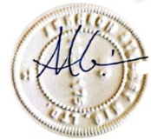
You are required to pay the sum of ₦70,000 for Property Offer processing fees.
Please accept our hearty congratulations!

FOR: AEMHECH SYNERGY NIG LTD
Mubarak Bala
MD/CEO

MEMORANDUM OF ACCEPTANCE

I MUKTAR IBRAHIM hereby accept this property offer letter on this day dated 21/05/2026 of which this is a copy.

Name: MUKTAR IBRAHIM
Address: KOFAR FADA AZARE
Signature: _____________________________________

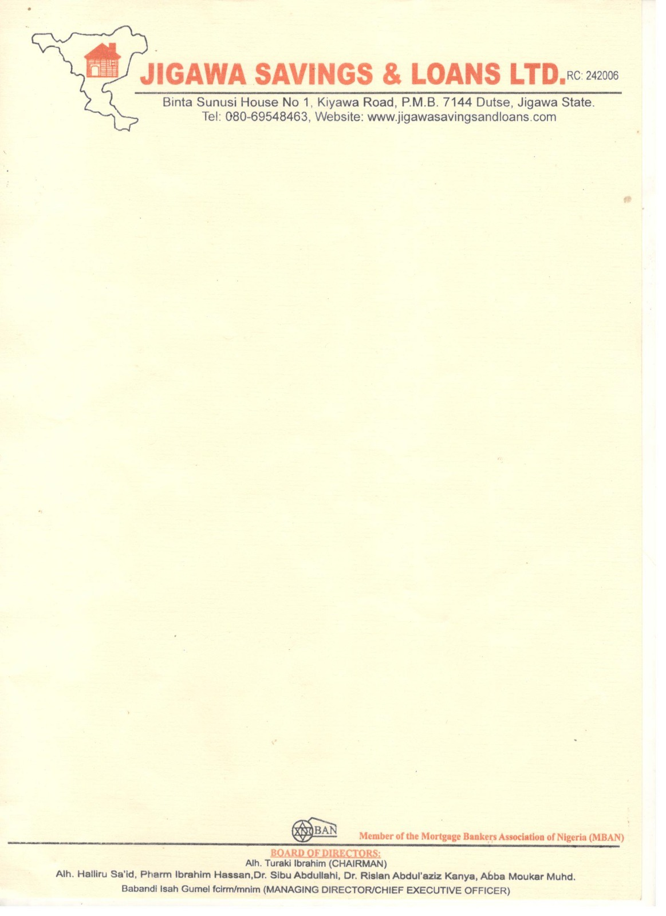


14th July, 2026
The Managing Director,
PREMIUM PENSION LIMITED,
4 Awgu Close, Off Faskari Crescent Area 3,
Garki, Abuja.

LETTER OF INDEMNITY IN RESPECT OF RETIREMENT SAVINGS ACCOUNT EQUITY CONTRIBUTION
THIS INDEMNITY is issued by Jigawa Savings and Loans Limited of Binta sanusi house, No. 1 Kiyawa Road, Dutse, Jigawa State (hereinafter called “Indemnifier” which expression where the context so admits include its successors-in-title and assigns), to PREMIUM PENSION LIMITED having its Head Office at 4 Awgu Close, Off Faskari Crescent Area 3, Garki, Abuja (Hereinafter called “PREMIUM Pensions” which expression shall where the context so admits include its successors-in-title and assigns)

WHEREAS:
- PREMIUM PENSION is a Pension Fund Administrator licensed by the National Pension Commission (“the Commission”) to manage individual Retirement Savings Accounts (RSA) in accordance with the provisions of the Pension Reform Act, 2014 (“the Act”);
- Pursuant to the Act, the Commission has issued Guidelines on Accessing RSA Balance towards Payment of Equity Contributions for Residential Mortgage (“Guidelines”) which Guidelines permit RSA Account Holders to access a portion of their RSA balance as equity contribution towards acquiring a residential property from a licensed financial institution;
- The Indemnifier is duly licensed by the Central Bank of Nigeria (CBN) and meets all the eligibility criteria for the provision of mortgage lending services to RSA holders under the Guidelines issued by the Commission.
- The Indemnifier has received applications from several RSA holders who maintain RSAs with PREMIUM PENSION and in line with the Guidelines, the indemnifier has agreed to finance the purchase of a residential property on behalf of the RSA holders, subject to the execution of relevant mortgage contracts.
- MUKTAR IBRAHIM, the RSA holder has requested and authorized that a portion of his/her RSA balance should be utilized as equity contribution to facilitate his/her mortgage and has applied to PREMIUM PENSION to release to the indemnifier, a portion note more than 25% of his/her RSA balance as equity contribution towards the acquisition of a residential mortgage.
- The indemnifier has conducted all requisite due diligence to confirm the authenticity of the RSA holder’s intended acquisition of a residential property and undertakes to PREMIUM PENSION that the portion of the RSA holder’s fund which shall be released to the Indemnifier on the RSA holder’s request shall be applied solely as equity contribution towards the acquisition of a residential mortgage, under the mortgage agreement between the indemnifier and the RSA holder; and shall not, under any condition, be released to the RSA holder or any third party for any other purpose.

- PREMIUM PENSION agrees to release the relevant portion of the RSA holder’s fund to the indemnifier and has requested that the Indemnifier provides this indemnity in favour of PREMIUM PENSION in the manner hereinafter stated.

NOW THEREFORE, in consideration of PREMIUM Pensions effecting the transfer of the portion of the RSA holder’s balance to the indemnifier as equity contribution by the RSA whose holder whose RSA PIN herein appears, towards acquisition of residential property in accordance with the Guidelines, We, Jigawa Savings and Loans Limited hereby irrevocable and unconditionally covenant that we shall at all times hereafter, indemnify PREMIUM PENSION and keep PREMIUM PENSION fully indemnified against all claims, demands, liabilities, actions, damages, penalties and legal proceedings (including any cost of litigation) which may be incurred by PREMIUM PENSION in the event that the fund so released by PREMIUM PENSION is not utilized as equity contribution towards the purchase of a residential property on behalf of the RSA holder.
Furthermore, Jigawa Savings and Loans Limited undertakes to pay PREMIUM PENSION on demands, liabilities, actions, damages and expenses (including but not limited to legal fees) incurred by the PREMIUM PENSION from acceding the RSA holder’s request to release funds from his/her RSA, in the event that the fund so released by PREMIUM PENSION is not utilized as equity contribution towards the purchase of a residential property on behalf of the RSA holder.
This Indemnity shall be continuing security and shall be enforceable from the date of disbursement of the portion of the RSA holder’s balance to the Indemnifier and shall inure to the benefit of PREMIUM PENSION up until the utilization of the funds so released, as equity contribution towards the acquisition of the residential property in favour of the RSA holder by the Indemnifier
This Indemnity shall not be enforceable against the Indemnifier for any claims, demands, of litigation, arising from any dispute or breach howsoever, in the contractual relationship between the PREMIUM PENSION and the RSA holder.
The indemnification provided under this indemnity by the Indemnifier shall be completely discharged upon the utilization of the portion of the RSA holder’s balance towards the purchase of a residential property in favour of the RSA holder by the Indemnifier.
RSA HOLDER | RSA PIN
MUKTAR IBRAHIM | PEN100653061410
This indemnity shall be governed by and construed in accordance with the extant laws of the Federal Republic of Nigeria.
THE COMMON SEAL of the within named INDENIFIER JIGAWA SAVINGS AND LOANS LIMITED was hereunto affixed I the presence of:

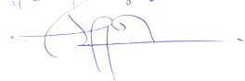
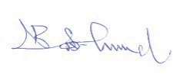

Director Director/Secretary
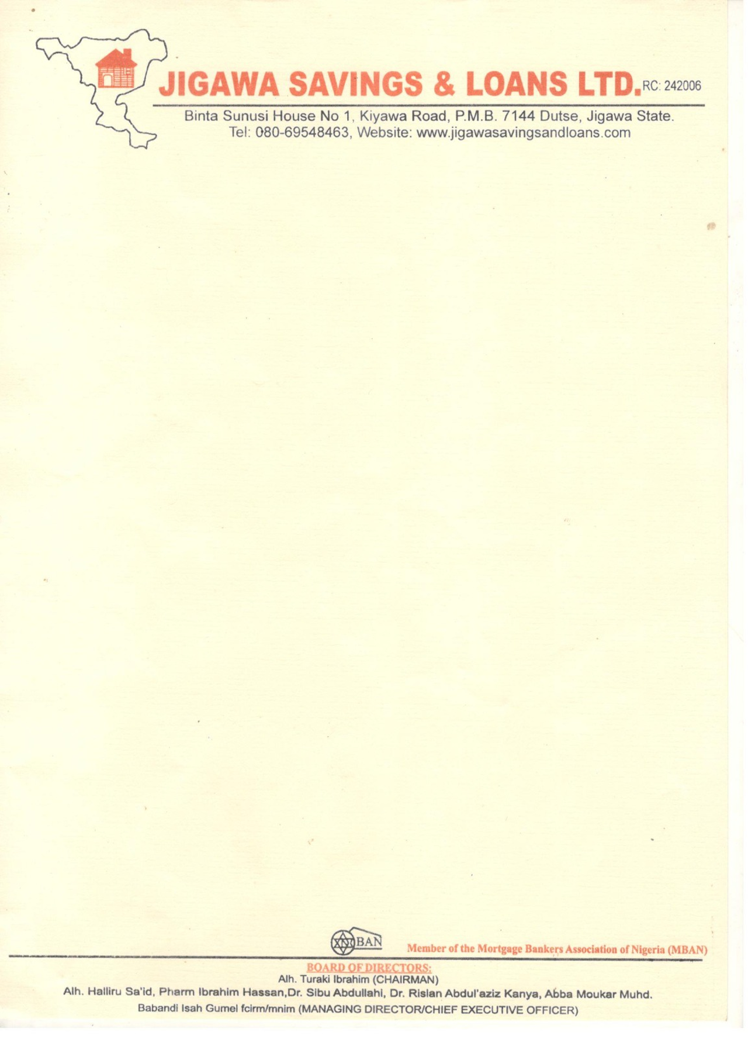

14th July, 2026
The Managing Director,
PREMIUM PENSION LIMITED,
4 Awgu Close, Off Faskari Crescent Area 3,
Garki, Abuja.

Dear Sir,

VERIFICATION OF OFFER LETTER FOR THE PURECHASE OF AN EXECUTIVE 1 BEDROOM SEMI-DETACHED FLAT AT JIBI VILLAGE, DEI DEI ROAD, KUBWA EXPRESS, ABUJA/NIGER STATE
The above subject matters refer.
The property was visited on the 20th February, 2026 to ascertain the availability of the property.
The property an EXECUTIVE 1 BEDROOM SEMI-DETACHED FLAT, AT JIBI VILLAGE, DEI DEI ROAD, KUBWA EXPRESS, ABUJA/NIGER STATE
Offered to MUKTAR IBRAHIM. The sale value of the property as of date is ₦770,033.62 (SEVEN HUNDRED SEVENTY THOUSAND, THIRTY-THREE NAIRA AND SIXTY-TWO KOBO) ONLY.
In view of forgoing, ‘We confirm the authenticity of the property offer letter and other documents’ as well as the availability of the property for sale.
Thanks for your usual co-operation.
Yours faithfully,
For: Jigawa Savings and Loans Limited

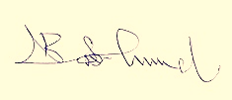
_______________________ _____________________
Aminu Jinjiri Babandi Isah Gumel
Head of Mortgage Managing Director/CEO

14th July, 2026
MUKTAR IBRAHIM
KOFAR FADA AZARE.
Dear Sir,

INDICATIVE OFFER LETTER OF A MORTGAGE LOAN OF ₦200,000.00 (TWO HUNDRED THOUSAND NAIRA) ONLY FOR THE PURCHASE OF EXECUTIVE 1 BEDROOM SEMI-DETACHED FLAT AT JIBI VILLAGE, DEI DEI ROAD, KUBWA EXPRESS, ABUJA/NIGER STATE.
Further to your application Mortgage Loan Jigawa Savings and Loans Limited (JSL) is pleased to offer you a Mortgage Loan of ₦ 200,000.00 (Two Hundred Thousand Naira) only, subject to the following terms and conditions.
Borrower - MUKTAR IBRAHIM
Lender - Jigawa Savings and Loans
Type of facility - JSL Loan
Property Amount - ₦ 770,033.62
Facility Amount - ₦200,000.00
Purpose - for the purchase of Executive 1 Bedroom Semi-detached flat,
Jibi, village, Dei Dei Road, Kubwa Express, Abuja/Niger State.
Equity - ₦ 570,033.62 (to be contributed from: 25% RSA Equity
Contribution)
Tenor - 7 years effective from the date of disbursement
Repayment plan - The principals together with the accrued interest shall
Be repaid in 12 equal monthly repayments of ₦ 19,166.67
Interest Rate: - 15% per annum on amity basis
ACCOUNT DETAILS WITH MORTGAGE LENDER:
ACCOUNT NAME: MUKTAR IBRAHIM
ACCOUNT NUMBER: 0001444769
BANK: JIGAWA SAVINGS AND LOANS LIMITED
Kindly use the above account details for the payment of the 25% funds upon approval in favour of the customer

Repayment source:- The mortgage facility shall be repaid by monthly repayment deduction from the Mortgagor’s salary or/ and business proceeds.
Security - The facility shall be secured by the following
First Legal Mortgage over property to the Mortgage.
- Direct deduction through Remita or IPPIS
- Duly executed Irrevocable Letter of Authority for the Domiciliation of Mortgagor’s Terminal Benefits with JSL
- Letter of Undertaking to Offset any outstanding obligation with JSL noted as loss payee.
Insurance: JSL shall on behalf and at the cost of the Mortgagor Comprehensively insure the property with a reputable insurance company against fire and other special perils with JSL noted as loss payee.
Disbursement: The facility amount shall be disbursed in full into the mortgagor current account.
STATUTORY PAYMENT REQUIREMENT:
Charges:
- Management fee of 1% flat of the approved loan amount of ₦2,000 Payable upfront to JIGAWA SAVINGS AND LOANS LIMITED.
- Fees of stamping, registration, perfection and other statutory fees payable to the appropriate authorities shall be communicated in due course
- Processing fee of 2% flat of the 25% RSA equity contribution fund in the sum of ₦11,400.67
CONDITIONS PRECEDENT TO DISBURSEMENT
- Receipt of the duly executed offer later by the mortgagor accepting the terms and conditions of the facility.
- Payment of all outstanding charges and fees upfront.
- Deposit of equity contribution ₦ 770,033.62 to be contributed by the RSA equity fund
- Execution of all loan with JSL These include
- JSL’s Loan Agreement
- Deed of Legal Mortgage on the Collateral Property
- Deed of Assignment on the Collateral Property
- Irrevocable Power of Attorney on the Collateral Property
- Indemnity clause not to divert funds
5. Receipt of up-to-date payment of ground rent and/or land use charge receipts
6. Submission of Photo Identification of the mortgagor
7. Receipt of current tax clearance certificate of the mortgagor
8. Deposit for the cost of perfecting title in favour of Jigawa Savings And Loans Limited
9. Submission of duly executed letter of domiciliation of Terminal Benefits
10. Opening of current account with JSL by the Mortgagor
11. Receipt of evidence of compliance with all the Insurance conditions.
12. Receipt of undertaking from the Mortgagor to regularly find the current account for monthly repayment of the loan, annual Insurance premium, ground rent and other related charges
13. Submission of original registered Title Document of the collateral property (C of 0. Deed of Assignment or Deed of Transfer or Deed of Conveyance)
14. Submission of duly signed consent letters authorizing JSL to disclose information to Credit Reference Agencies to determine history and rating of the mortgagor.
15. Disbursement is subject to receipt of 25% of RSA Contribution
16. Receipt of undertaking of set-off of the loan and other dues from the mortgagors account as and when due.
17. The Mortgagor providing 1 year premium for property insurance policy as first loss payee
18. All costs and expenses incidental to the processing, monitoring documentation, disbursement, and recovery of the facility, including the perfection of the Security Collateral Property as well as the cost of enforcing the terms and conditions therein. Shall be fully bome by the Mortgagor
19. Payment of 2% penalty fee on loan balance for early liquidation of loan.
STAND BY CREDIT LINE
- All termly repayment of the loan, annual premiums, ground rent and related charges shall be debited to the mortgage’s current account under advice.
- In the event the mortgagee’s current account is not funded to meet any of the payment (refereed to in 1 above) JSL shall provide a stand-by credit line in form of an overdraft to meet such payments.
- In the events of 2, above, the mortgage still pay a management fee 1% of any amount outstanding in the account per month in addition to interest to interest at the Bank’s leading rates as may be determined from time to time.
- The security for the stand-By credit Line shall be the subject property
- In the event of delay in the repayment due to an unforeseen occurrence, the Mortgagor must escalate same to the bank prior to payment due to date and must subsequently apply in writing for a short terms overdraft to cover the period as clause (2) above.
2. Some Remedies for Defaults
The Bank remedies against the Borrower’s defaults included buy not limited to:
- The bank is also authorized to liquidate all other collaterals provided by me in the cause of security this approval: by way of outright sale of such collaret and the proceeds should be used to clean up, y outstanding.
- The facility shall become payable. The mortgage by accepting this offer has by way of first priority hereby assigned a security Jigawa Savings And Loans Limited, the collated property with the building (s) erected thereon. The bank cam therefore, exercise its full right of FORCLOSUE OUTRIGHT SALE without any recourse to the Borrower
- Irrevocable and unconditional authority to JSL to publish the Borrower’s name without any recourse to the Borrower’s newspaper circulating within Nigeria.

“By signing this offer letter/loan agreement and by drawing on the loan as and when due. In the I fail to repay the loan as agreed, and the loan becomes delinquent, the bank shall have the right to the report the delinquent loan to the CBN through the credit Risk Management System (CRMS) or by any other means, and request that CBN exercise its regulatory power to direct all banks and other financial Institutions under its regulatory purview to set – off my indebtedness from any money standing to my credit in any bank account and from any other financial assets they may be holding for my benefit.
I covenant and warrant that the bank shall have power to set – off my indebtedness under this loan agreement from all such monies and funds standing to my credit/benefit it any and all such accounts or from any other financial assets belonging to me and in the custody of any such bank.

I Covenant and warrant that the bank shall have power to set-off my indebtedness under this loan agreement from all such monies and funds standing to my credit/benefit in any and such accounts or from any other financial assets belonging to me and in the custody of any such bank.
MUKTAR IBRAHIM
22245549762
I with BVN

And NIN hereby undertake that in case of any incapacitation or sudden demise in the course of the loan, Jigawa savings and loans LTD is permitted to offset our outstanding loan balances from the sales of our property used as collateral for this loan.

__________________________________
Borrower’s Signature/Date
I HAVE READ AND UNDERSTOOD THE CONTENT OF THIS OFFER LETTER AND HEREBY AGREED/CONSENT TO SAME
If the foregoing terms and conditions are acceptable to you, please indicate your acceptance by signing the attached duplicate copy of this letter and return to us failing which the offer shall lapse without any liability or commitment on the part of JSLL.
Yours Faithfully
For: JIGAWA SAVINGS AND LOANS LTD
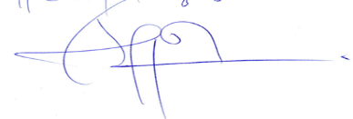 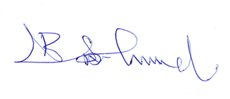Aminu Jinjiri Babandi Isah Gumel
Head Of Mortgage Managing Director/CEO

UNDERTAKING
I MUKTAR IBRAHIM Hereby undertake and consent to the monthly deductions of the monthly repayment from my current account until the loan is fully understood all the duration of the Mortgage and hereby confirm that I have read and understood all the terms and conditions of this offer.
Signature: Date: 14th July, 2026
OFFER ACCEPTED BY: In the Presence of:
HALIMA MUKTAR
MUKTAR IBRAHIM
Name: Name:
Signature: ………………………………… Signature: …………………………………
14th July, 2026
14th July, 2026
Date: ………………………………………. Date: ………………………………………
Mobile number: 08034275466 Mobile number: 08034275466



VALUATION REPORT

ON
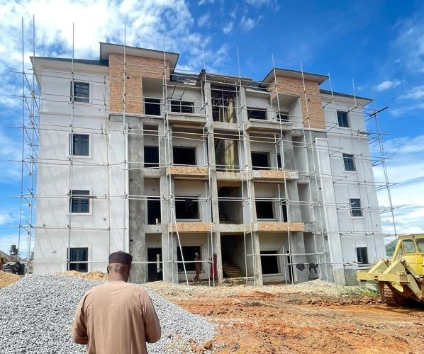
PROPERTY LOCATED AT JIBI VILLAGE, DEI DEI ROAD, KUBWA EXPRESS, ABUJA/NIGER STATE.

FOR
MUKTAR IBRAHIM


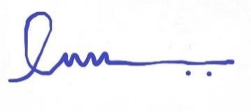
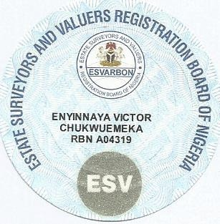
CERTIFICATE OF VALUE

DATE OF VALUATION: 10th June, 2026
PURPOSE OF VALUATION: Determination of Fair Market/Forced
Sale Values

This is to Certify
That the Fair Market Value of the Interest in the subject landed property situated at JIBI VILLAGE, DEI DEI ROAD, JIBI EXPRESS, ABUJA/NIGER STATE, as at the above valuation is in the sum of ₦770,033.62 (SEVEN HUNDRED SEVENTY THOUSAND, THIRTY-THREE NAIRA AND SIXTY-TWO KOBO only) and the Forced Sale Value in the sum of ₦470,033.62 (FOUR HUNDRED SEVENTY THOUSAND, THIRTY-THREE NAIRA AND SIXTY-TWO KOBO only).

We hereby certify that the above exercise has been carried out in conformity with the Professional standards of the Nigerian Institution of Estate Surveyors and valuers of which we are registered members.

Given under our Seal and Witnessed by the Signature of our Principal Consultant by Virtue of Powers conferred upon him by the Estate
Surveyors And Valuers Registration Board of Nigeria

This 10th Day of June, 2026


VAL/ABJ/VEC/2026
10th June, 2026.
The Managing Director
Jigawa Savings and Loans Limited
Binta Sunusi House No 1, Kiyawa road, Dutse.
Jigawa State.
Dear Sir,
VALUATION OF PROPERTY LOCATED AT JIBI VILLAGE, DEI DEI ROAD, JIBI EXPRESS, ABUJA/NIGER STATE.
Further to your recent instruction requesting us to undertake a Valuation of the above-­captioned property, we have carried out the inspection and valuation of same and now have the pleasure in reporting to you as follows:
DATE OF INSPECTION:
Our inspection was undertaken on Saturday the 10th day of June, 2026.
- PROPERTY
LOCATION:
Access to the property is either via Jibi Village, Dei Dei Road, Jibi Express, Abuja/Niger State.
Driving from Jibi Express Way Abuja to Dei Dei in Niger State and right turn will lead you to Jibi Village, the area is adjacent to Brain Hammers Estate in the same Jibi Village in Tafa LGA, Niger State.

The Neighborhood Comprise of mainly residential buildings.

VICTOR ENYINNAYA ASSOCIATES

ACCESSIBILITY:
The roads are tarred to the estate.
Basic infrastructural facilities such as electricity, pipe-­borne water, telecommunication and adequate road network are available within the precinct.

DESCRIPTION:
Our interest is on a single unit of Executive 1 Bedroom Semi-detached flat.
- NEIGHBOURHOOD:

JIBI DISTRICT:
Jibi is a fast developing district in Niger State. It is a mixed of high income and middle class relatively secured area which is located in Niger State, but very close to the FCT--Abuja. Jibi is residential development. It is home to several estates, mostly new and under construction couple with commercial buildings. Jibi district boasts well tarred and untarred roads, very good transportation networks too.
PREDOMINANT HOUSING UNIT:
Housing types within the neighborhood comprise mainly of Terrace duplex, block of flats, semi-­detached and fully detached duplex.
Notable structures within the precinct are Brain and Hammers estate.

VICTOR ENYINNAYA ASSOCIATES
- VALUATION:
CONSTRUCTIONAL DETAILS:
The unit will upon completion, have the following constructional details:

1 BEDROOM BLOCK OF FLAT
Construction is of sandcrete block walls.
The walls are rendered smooth and finished with emulsion paint.
The floors are of the reinforced mass in-­situ concrete, finished with ceramic tiles The doors are of the security type.
The windows are of the aluminum swing type.
The ceiling is of the Plaster of Paris (P.O.P) type.
The roof is of the aluminum long span roofing sheet type nailed unto timber trusses.

ACCOMMODATION DETAILS:
The following are the details of accommodation provided in the building: MAIN BUILDING
- Living room
- Dining
- Guest toilet
- Kitchen
- 1 Bedroom ensuite

VICTOR ENYINNAYA ASSOCIATES
TOPOGRAPHY/SITE:
The site is regular in shape, appears firm, leveled and well drained.
TITLE:
The title document to the property is Letter of intent (Mass Housing) title to the property is good and marketable.
This is however subject to the provisions and limitations of the Land Use Decree No. 6 of 1978.
However, we did not carry out a title search on the property and no responsibility is assumed for matters legal in character.
METHOD OF VALUATION:
- We have valued the property in the open market using the direct comparison method of valuation.
The direct comparison method involved our analysis of similar properties that have recently been transacted upon in the open market within the locality and adjusting appropriately to take care of the peculiarities and level of completion of the subject property in arriving at the value.
CONDITION:
The buildings are in a good state of structural and decorative repairs.
However, we did not carry out a structural survey of the buildings, neither did we examine nor test their services. We are, therefore, unable to comment in this regard.
Similarly, we did not inspect the materials used for the construction and cannot give any guarantee or assurance that they are free from rot, woodworm or any such infestations.

VICTOR ENYINNAYA ASSOCIATES
SCHEDULE OF CONDITION
S/N | BUILDING COMPONENTS | DEFECTS | REMARK
1 | Wall | None | None
2 | Doors | None | None
3 | Floor | None | None
4 | Window | None | None
5 | Roof | None | None
INFORMATION:
Information given in this report have been obtained as follows:
- as regards the descriptive and locational details from visual inspection of the property; ;
- as regard the value from analysis of open market transactions on similar properties in the neighborhood;
- as regards the title, from assumptions made by us.

ASSUMPTIONS:
In valuing the property, we have assumed:
- that the information with which we are supplied are correct;
- that the title to the property is good and marketable;
- that the property is not adversely affected by or subject to compulsory acquisition, road widening, new proposal or planning scheme;
- that the property is free from all onerous charges and restrictions.

VICTOR ENYINNAYA ASSOCIATES


VALUATION BASIS:
The basis of valuation is the Market value, that is, the price, which an interest in a property might reasonably be expected to realize in a sale by Private Treaty assuming:
  - a willing buyer;
  - a reasonable period within which to negotiate the sale taking into account the nature of the property and the state of the market;
  - values will remain static throughout the period;
  - the property will be freely exposed to the market;
  - no account is to be taken of an additional bid by a special purchaser;
  - no account is to be taken of expenses of realization, which may arise in the event of a disposal.

CERTIFICATION:
In carrying out our valuation, we certify that:
- statement of facts with regards to this report are true and correct to the best of our knowledge;
- Limiting conditions have been disclosed;
- we have no interest (present or future) in the transaction or property;
- Compensation was not contingent upon us rendering our opinion of value;
- We have complied with all valuation standards as required;
- An inspection of the property was conducted;
- Assistance was not received in the execution of the valuation report.

VICTOR ENYINNAYA ASSOCIATES
OPINION:
WE ARE OF THE OPINION that the Market value of the above-­captioned property as at the 10th of June, 2026 is in the sum of ₦770,033.62 (SEVEN HUNDRED SEVENTY THOUSAND, THIRTY-THREE NAIRA AND SIXTY-TWO KOBO ONLY).

WE ARE FURTHER OF THE OPINION that the Forced sale value of the above-­captioned property as at the 10th Day of June, 2026 is in the sum of ₦470,033.62 (FOUR HUNDRED SEVENTY THOUSAND, THIRTY-THREE NAIRA AND SIXTY-TWO KOBO Only).
This Certificate is issued for the use of the addressee only and no responsibility is accepted from any third party for the whole of its contents or any part thereof.

If our opinion of value is to be disclosed, the basis of our valuation should please be stated and if our figure is to be published, it will be necessary for our prior consent to be obtained for the form and context in which it will be published.



VICTOR ENYINNAYA ASSOCIATES

ALLY MICROINSURANCE LIMITED
Suite C4, 29 Ndjamena Crescent Wuse II, Abuja. Email: allymicroinsurance@gmail.com
Tel: +2348165555948

CERTIFICATE OF INSURANCE

FIRE MICROINSURANCE PLAN

POLICY NO: ALLY/2026/FIR/0455
NAME OF POLICY HOLDER:
MUKTAR IBRAHIM
ADDRESS: BINTA SANUSI HOUSE, NO. 1 KIYAWA ROAD, DUTSE, JIGAWA STATE.

NAME OF PROPERTY: EXECUTIVE 1 BEDROOM SEMI-DETACHED FLAT

ADDRESS OF PROPERTY: JIBI VILLAGE, DEI DEI ROAD, JIBI EXPRESS, ABUJA/NIGER STATE.
EFFECTIVE DATE:
25/05/2026
EXPIRATION DATE:
24/05/2027

GROSS PREMIUM: ₦ 1,617.07
SUM ASSURED: ₦ 770,033.62

We hereby certify that the policy to which this certificate relates is issued in accordance with the NATIONAL INSURANCE COMMISSION MICROINSURANCE GUIDELINE 2018.:
Examined:
GABRIEL LOT-LINUS Authorized Signature



ALLY MICROINSURANCE LIMITED
Suite C4, 29 Ndjamena Crescent Wuse II, Abuja.
Email: allymicroinsurance@gmail.com
Tel: +2348165555948

CERTIFICATE OF INSURANCE

CREDIT LIFE MICROINSURANCE PLAN


POLICY NO: ALLY/2026/CRT/0461
MUKTAR IBRAHIM
NAME OF POLICY HOLDER:
ADDRESS: BINTA SANUSI HOUSE, NO. 1 KIYAWA ROAD, DUTSE, JIGAWA STATE.
NAME OF PROPERTY: EXECUTIVE 1 BEDROOM SEMI-DETACHED FLAT

ADDRESS OF PROPERTY: JIBI VILLAGE, DEI DEI ROAD, JIBI EXPRESS ABUJA/NIGER STATE.
EFFECTIVE DATE:
25/05/2026
EXPIRATION DATE:
24/05/2027
SUM ASSURED: ₦ 200,000.00

GROSS PREMIUM: ₦ 2,000.00

We hereby certify that the policy to which this certificate relates is issued in accordance with the NATIONAL INSURANCE COMMISSION MICROINSURANCE GUIDELINE 2018.
Examined:
GABRIEL LOT-LINUS Authorized Signature


14th July, 2026.
The Managing Director,
PREMIUM PENSION LIMITED,
4 Awgu Close, Off Faskari Crescent Area 3,
Garki, Abuja.

Dear Sir,

CONFIRMATION OF THE PROPERTY AVAILABILITY FOR MUKTAR IBRAHIM
We hereby write to official conform that the property a 1 Unit of Executive 1 Bedroom Semi-detached flat at JIBI VILLAGE, DEI DEI ROAD, KUBWA EXPRESS, ABUJA/NIGER STATE
Offered to MUKTAR IBRAHIM
Is very much available.
Please go ahead with his 25% RSA Residential Mortgage.
Thank you for your co-operation

For: Jigawa Savings and Loans Limited

_______________________ _____________________
Aminu Jinjiri Babandi Isah Gumel
Head of Mortgage Managing Director/CEO

14th July, 2026.
The Managing Director,
PREMIUM PENSION LIMITED,
4 Awgu Close, Off Faskari Crescent Area 3,
Garki, Abuja.

Dear Sir,

CONFIRMATION OF TITLE DOCUMENT OF PROPERTY KNOWN AS 1 UNIT OF EXECUTIVE 1 BEDROOM SEMI-DETACHED FLAT, AT JIBI VILLAGE, DEI DEI ROAD, KUBWA EXPRESS, ABUJA/NIGER STATE IN FAVOUR OF MUKTAR IBRAHIM PIN:PEN100653061410
We refer to the above subject and wish to confirm that a search was conducted to confirm the authenticity of the property document and it was confirmed that the property is free from all encumbrances.
We do hope this will assist you in the final processing
While we appreciate you for your anticipated cooperation, please note that we are duly prepared for immediate disbursement of the funds to the rightful beneficiary.
Thank you for your usual cooperation
Yours faithfully
For: Jigawa Savings and Loans Limited
_______________________ _____________________
Aminu Jinjiri Babandi Isah Gumel
Head of Mortgage Managing Director/CEO

14th July, 2026.
The Managing Director,
PREMIUM PENSION LIMITED,
4 Awgu Close, Off Faskari Crescent Area 3,
Garki, Abuja.

Dear Sir,

EXPRESSION OF READINESS TO DISBURSE LOAN
We hereby express our readiness as a Mortgage Bank to disburse a loan of N200,000.00 Two Hundred Thousand Naira Only to MUKTAR IBRAHIM with Jigawa Savings and Loans Mortgage Bank Account Number 0001444769.
Kindly credit the customer account details stated above with the sum of ₦570,033.62 Only being his 25% retirement savings, as an equity contribution for the purchase of a 1 UNIT OF EXECUTIVE 1 BEDROOM SEMI-DETACHED FLAT AT JIBI VILLAGE, DEI DEI ROAD, KUBWA EXPRESS, ABUJA/NIGER STATE.
Alternatively, you can transfer the fund to our Sterling Bank account details below:
Account name: Jigawa Savings and Loans Limited Account
Number: 0007873093
Narration: 25% equity contribution for MUKTAR IBRAHIM-0001444769

Thank you for your anticipating co-operation
Yours faithfully,

For: Jigawa Savings and Loans Limited
_______________________ _____________________
Aminu Jinjiri Babandi Isah Gumel
Head of Mortgage Managing Director/CEO

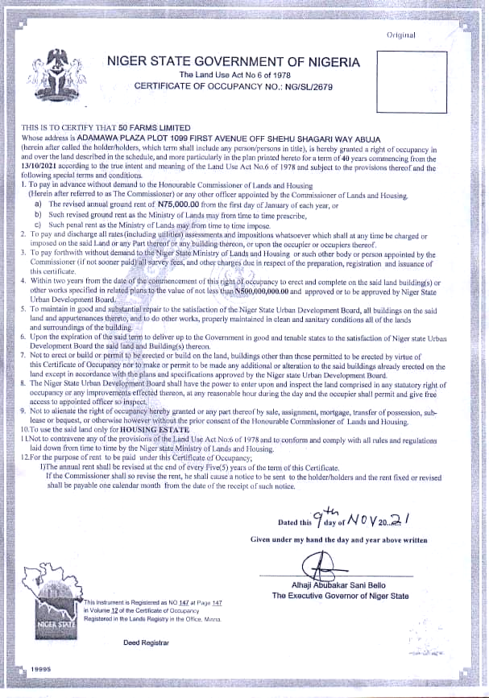

Approval

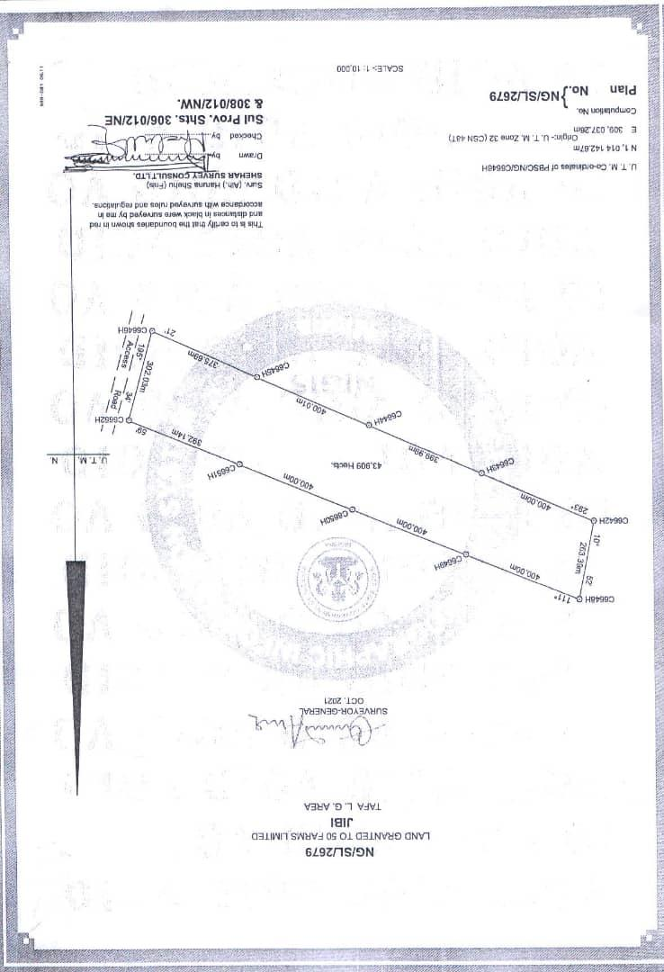
C of O

LEGAL SEARCH REPORT IN RESPECT OF NIGER STATE GOVERNMENT OF NIGERIA CERTIFICATE OF OCCUPANCY NO. NG/SL/2679 DATED 9th NOVEMBER, 2021 ISSUED BY THE NIGER STATE GOVERNMENT IN FAVOUR OF MUKTAR IBRAHIM.
- Date and Time of Search: 2nd June, 2026 at 3:48 PM
- Place of Search: Niger State Urban Development Board
- Full Description of Land: All that parcel of land measuring approximately 439,090 m² square metres described and known as Jibi Village, Dei Dei Road, Kubwa Express, Abuja/Niger State.
- Parties: 1. NIGER STATE URBAN DEVELOPMENT
BOARD(Grantor) AND
2. MUKTAR IBRAHIM (Grantee)
- Description of Title Document: Offer of Grant of Development Lease File No. NG/SL/2679 dated 9th November, 2021 issued by the Grantor in favour of the Grantee.
- Term/Commencement Date: Twenty-four (24) months commencing from the 9th November, 2021.
- Purpose Commercial/Mass Housing Development
- Notable/Special Terms Clause 4 of the Title Document search provides that the holder shall not build or permit to

be built on the said land any buildings other than those approved to be built by the aforementioned Title Document.

Clause 8 of the Title Document search provides that within 24 months from the date of commencement of the Grant of the Offer, the Grantee must erect buildings on the land in conformity with the purpose for which the land was granted.
Clause 9 of the Title Document search provides that the holder is not to alienate the right of occupancy granted either by way of sale, assignment, mortgage or sublease (inter alia) without the prior written consent of the Niger State Urban development Board.
- Notable Observation: 1. MUKTAR IBRAHIM application dated 9th November, 2021 for direct allocation for land use for mass housing was acknowledged.
  - Also sighted was proof of payment of N75,000 for processing of the aforementioned application.
  - A Deed of Development Lease dated 9th November, 2021 between Niger State Urban Development Board and MUKTAR IBRAHIM for the
development of mass housing was sighted.
  - The Offer of Grant of Development Lease dated 24th June 2024 issued by the Niger State Urban Development Board in favour of MUKTAR IBRAHIM was
sighted.
  - Sighted on search was the initial Bill for the Offer and Letter of Acceptance by MUKTAR IBRAHIM but no evidence of the payment of the Initial Bill.
  - by a Memorandum of Agreement dated 1st January, 2025 between MUKTAR IBRAHIM
on the one hand and AEMHECH SYNERGY NIG LTD on the other hand, AEMHECH SYNERGY NIG LTD
was handed over 18 hectares of land carved out from the parcel of land measuring 439,090 m² square metres for the construction of housing estate.
  - AEMHECH SYNERGY NIG LTD has
parcellated the said 43 hectares of

land into a layout, which has been duly approved by NIGER STATE URBAN DEVELOPMENT BOARD and
has constructed mixed house types on the afore-stated land called the AEMHECH SYNERGY investment estate, to be sold to members of the public.
  - AEMHECH SYNERGY NIG LTD has,
via a Property Sale Offer Letter offered a portion of the said land with the building thereon to MUKTAR IBRAHIM
- Charges/Encumbrance: As at the date and time of this search, there is no evidence at NIGER STATE URBAN DEVELOPMENT BOARD of any
charges or encumbrances against the Title Document which will prevent the alienation on and transfer of a portion of the land with the building thereon by MUKTAR IBRAHIM through AEMHECH SYNERGY NIG LTD in favour of MUKTAR IBRAHIM by way of sale.

We conclude that under the aforementioned Memorandum of Agreement dated 2nd June, 2026 in 9 .6 above, the Property Sale Offer Letter issued by AEMHECH SYNERGY NIG LTD is valid. MUKTAR IBRAHIMhas good title to the land search against and its power to alienate its interest in a portion of the said land through AEMHECH SYNERGY NIG LTD to MUKTAR IBRAHIM by way of assignment is un-encumbered.


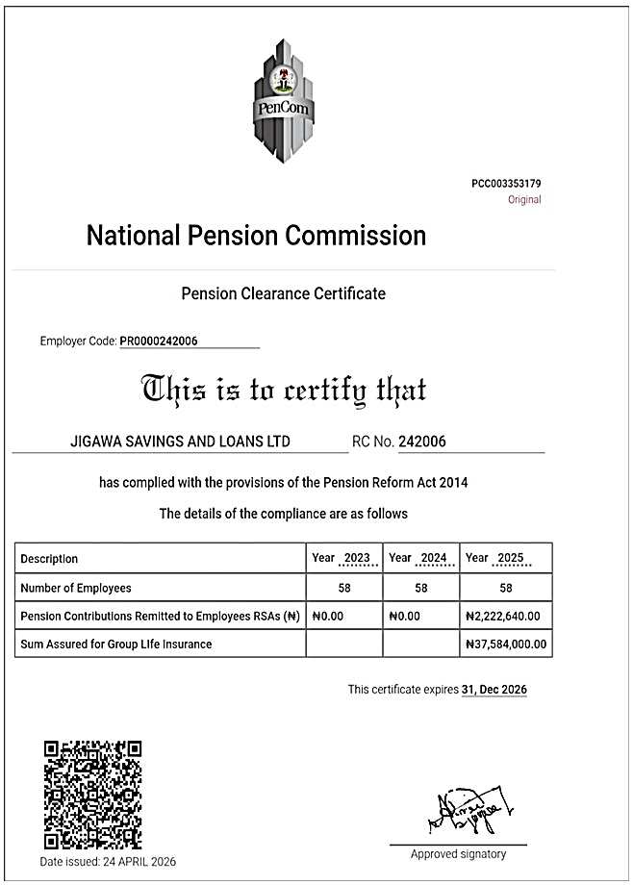
PENCOM

MUKTAR IBRAHIM | Account Number: | 0001444769
KOFAR FADA AZARE | Account Product: | 25% RSA CURRENT ACCOUNT
 | Branch Name: | HEAD OFFICE
 | Date From: | 01-Jul-26
 | Date To | 14-Jul-26  Bank Account Statement
 | Brought Forward: | 0.00Cr

Posting Date |  | Value Date |  | Transaction Narrative |  | Reference |  | Debit |  | Credit |  | Balance
14-Jul-26 |  | 14-Jul-26 |  | No transaction between 01- |  |  |  | 0.00 |  | 0.00 |  | 0.00Cr
 |  |  |  | Jul-2026 and 14-Jul-2026
Count: | 1 |  |  |  |  |  |  | 0.00 |  | 0.00
 |  |  |  |  |  |  |  |  |  | Carried Forward: |  |  | 0.00Cr

*** End of Statement ***


RC: 242006
JIGAWA SAVINGS & LOANS LTD

Binta Sanusi House, No. 1, Kiyawa Road, P.M.B 7144 Dutse, Jigawa State

25% RSA EQUITY FUND ASSESSMENT APPLICATION FORM

PFA DETAILS
MUKTAR IBRAHIM
- Name of Applicant (RSA holder): …………………………………………………………….
PREMIUM PENSION
- PFA: ………………………………………………………………………………………………………..
PEN100653061410
- PIN: …………………………………..…………………………………………………………………….
JIGAWA SAVINGS & LOANS LTD
- Name of Mortgage Lender : ……………………………………………………………………..
KOFAR FADA AZARE
- Address : ………………………………………………………………………………………………….
1 UNIT OF EXECUTIVE 1 BEDROOM SEMI-DETACHED FLAT
- Type and Address of property: …………………………………………………………………
AT JIBI VILLAGE, DEI DEI ROAD, KUBWA EXPRESS, ABUJA/NIGER STATE
………………………………………………..……………………………………………………………….
SINGLE
- Type of Mortgage Offer (Single or Joint): ………………………………………………….
- Evidence of Marriage(If in a joint mortgage): ……………………………………………
- PIN of spouse(If in a joint mortgage): ……………………………………………..………..
- PFA of spouse(If in a joint mortgage): ……………………………………………………….
- Amount of Equity payable by each applicant (If in a joint mortgage) :
₦570,033.62
…………………………………………………………………………………………………………………
0001444769
- Mortgage Account Number: ……………………………………………………………………
₦770,033.62
- Value of Property: …………………………………………………………………………………..
₦570,033.62
- Amount of Equity Payable: ……………………………………………………………………..
2/10/1984
- Date of Birth: ………………………………………………………………………………………….
- Sex: …………………………………………………………………………………………………………
- Marital Status: ………………………………………………………………………………………..

OTHER DETAILS
KOFAR FADA AZARE
- Residential Address: ………………………………………………………………………….......
……………………………………………………………………………………………………………….. Is it Owner-Occupier?…………………………..Or Rented?...................................
CIVIL SERVANT
- Occupation: ……………………………………………………………………………………………..
- Date Employed: ………………………………………………………………………………………
- Office Address: ………………………………………………………………………………………..
…………………………………………………………………………………………………………………
- Present Position: …………………………………………………………………………………….
08034275466
- Telephone No: ………………………………………………………………………………………..
- Mortgage Lender (Loan option as supplementary fund)
…………………………………………………………………………………………………………………

- Purpose of Loan Required: ……………………………………………………………………..
RESIDENTIAL MORTGAGE
- Amount of Loan Required: (In words/Figures) …………………………………………
₦200,000 (TWO HUNDRED THOUSAND NAIRA)
…………………………………………………………………………………………………………………
12 MONTHS
- Repayment Period: …………………………………………………………………………………
- Monthly Salary/ Income: ………………………………………………………………………..
SALARY
- Source of Loan Repayment: …………………………………………………………………..
22245549762
- BVN…………………………………………………………………………………………………………

- NIN………………………………………………………………………………………………………….

SPOUSE BIODATA
- Name: …………………………………………………………………………………………………….
- Address: ……….…………………………………………………………………………………………
…………………………………………………………………………………………………………………
- Occupation: …….………………………………………………………………………………………
- Address of Place of Work: …………………………………………………………………….…
…………………………………………………………………………………………………………………
- Present Rank : …………………………………………………………………………………………
- Date Employed (Public Servant only): ……………………………………………………..
- GSM Number : ………………………………………………………………………………………..

NEXT OF KIN BIODATA
HALIMA MUKTAR
- NAME: …………………………………………………………………………………………………….
KOFAR FADA AZARE
- Address: …………………………………………………………………………………………………
- Relationship: .………………………………………………………………………………………….
- Occupation: …………………………………………………………………………………………….
- Address of Place of Work: ……………………………………………………………………….
08034275466
- GSM Number :…………………………………………………………………………………………

DELARATION
I, Mal/Alh/Haj/Mr/Mrs hereby
MUKTAR IBRAHIM
declare that the above information are true and correct and I shall comply with any other terms and conditions as stipulated by the bank as requirements for the loan.
14th July, 2026
Signature: …………………………………………………. Date: ……………………………………………


APPLICATION FORM ON EQUITY CONTRIBUTIONS FOR RESIDENTIAL MORTGAGE
SECTION A
MUKTAR IBRAHIM
NAME OF APPLICANT …………………………………………………………………………………………….……………………………….
PEN100653061410
PIN NUMBER……………………………………………………………………………………………………….…………………………………….
Residential Single
TYPE OF MORTGAGE……………………………………………………………………………………………………….………………………
JIGAWA SAVINGS & LOANS LTD

NAME OF MORTGAGE LENDER ………………………………………………………………………………………………………………..
BINTA SANUSI HOUSE, NO. 1 KIYAWA ROAD, DUTSE, JIGAWA STATE
ADDRESS OF MORTGAGE LENDER………………………………………………………………………………………………………….
…………………………………………………………………………………………………………………………………………………………
Executive 1 Bedroom Semi-detached flat
NAME OF PROPERTY …………………………………………………………………………………………………………………………………
JIBI VILLAGE, DEI DEI ROAD, KUBWA EXPRESS, ABUJA/NIGER STATE
ADDRESS OF PROPERTY…………………………………………………………………………………………………………………………..
Residential
TYPE OF PROPERTY ………………………………………………………………………………………………………………………………….
₦770,033.62
VALUE OF PROPERTY………………………………………………………………………………………………………………………………..
₦570,033.62
EQUITY AMOUNT REQUIRED…………………………………………………………………….……………………………………………
₦2,280,134.47
RSA BALANCE AS AT DATE OF APPLICATION………………………………………………………………………………………
₦570,033.62
MAXIMUM EQUITY CONTRIBUTION FROM RSA……………………………………………………………………………………
₦570,033.62
EQUITY AMOUNT PAYABLE………………………………………………………………………………………………………………..
SUPPLEMENTARY EQUITY CONTRIBUTION AMOUNT PAID (WHERE 25% OF RSA IS LESS THAN EQUITY CONTRIBUTION) ……………………………………………………………………………………………………………………………
APPLICANT’S SIGNATURE………………………………………………………..DATE…………………………………………………….

SECTION B (FOR JOINT APPLICATONS ONLY)
NAME OF SPOUSE………………………………………………………………………………………………………………………………………
RSA PIN OF SPOUSE…………………………………………………………………………………………………………………………………..
PFA OF SPOUSE………………………………………………………………………………………………………………………………………….
EQUITY AMOUNT REQUIRED…………………………………………………………………….………………………………………….
RSA BALANCE AS AT DATE OF APPLICATION………………………………………………………………………………………
MAXIMUM EQUITY CONTRIBUTION FROM RSA……………………………………………………………………………………
EQUITY AMOUNT PAYABLE………………………………………………………………………………………………………………..
SUPPLEMENTARY EQUITY CONTRIBUTION AMOUNT PAID (WHERE 25% OF RSA ISLESS THAN EQUITY CONTRIBUTION) ………………………………………………………………………………………………………………………….

SECTION C
FOR OFFICIAL USE ONLY
PPL BRANCH OFFICE………………………………………………………………………………...................................
OFFICER ’S NAME…..……………………………………………………………………………………………………………………..
SIGNATURE………...…...……......…… ……………………DATE: …….…………………………...............................

For all enquiries; contact our Call Centre on 09 – 4615701 and/or Email: csu@premiumpension.com
RSA HOLDER INDEMNITY FORM

The Chief Executive Premium Pension Limited
No 4 Awgu, Off Faskari Crescent Area 3, Garki, Abuja
THIS INDEMNITY is issued by ……………………………….………………… of…..………….………………………….…………………….……………………………………………………………………………… (hereinafter called "the Indemnitor", which expression shall where the context so permits include its successors-in-title and assigns), to PREMIUM PENSION LIMITED, having its Head Office at No 4, Awgu Close, Off Faskari Crescent, Area 3, Garki, Abuja (hereinafter called "PREMIUM PENSION LIMITED", which expression shall where the context so permits include its successors- in-title and assigns)
MUKTAR IBRAHIM
KOFAR FADA AZARE
WHEREAS:
- PREMIUM PENSION LIMITED is a Pension Fund Administrator duly licensed by the National Pension Commission ("the Commission") to manage Retirement Savings Accounts (RSAs) in accordance with the provisions of the Pension Reform Act 2014 ("the Act");
- The Commission has, pursuant to the Act, issued Guidelines on Accessing RSA Balance towards Payment of Equity Contributions for Residential Mortgage ("Guidelines") which Guidelines permits an RSA holder to request for application of a portion of his/her RSA balance as equity contribution towards acquiring a residential property mortgage loan from a licensed financial institution;
- The Indemnitor is a holder of RSA with PIN
PEN100653061410
…………………………………….……….. and meets the eligibility criteria for the provision of receiving mortgage services under the Guidelines issued by the Commission.
- The RSA holder has undertaken to make equity contributions to facilitate his/her mortgage and has applied to PREMIUM PENSION LIMITED to release to the Mortgage Lender, a portion of his/her RSA balance as equity contribution towards his/her application for a residential mortgage.

Confidential

- PREMIUM PENSION LIMITED agrees to release the relevant portion of the Indemnitor's RSA balance to the Mortgage Lender and has requested that the Indemnitor provides this indemnity in favour of PREMIUM PENSION LIMITED in the manner hereinafter appearing.
NOW THEREFORE, in consideration of PREMIUM PENSION LIMITED effecting the transfer of the portion of the Indemnitor's RSA balance to the Mortgage Lender as equity contribution by the Indemnitor whose RSA PIN appears herein towards acquisition of residential property in accordance with the Guidelines, l, …………………………………………………………………………. hereby irrevocably and unconditionally undertakes and covenant that I shall at all times hereafter well and truly indemnify PREMIUM PENSION LIMITED and keep PREMIUM PENSION LIMITED fully indemnified against all losses, claims, demands, liabilities, actions, damages, penalties and proceedings including any cost of litigation which may be incurred by PREMIUM PENSION LIMITED in acceding to my request to transfer funds from my RSA to the Mortgage Lender.
MUKTAR IBRAHIM
This Indemnity shall be a continuing security and shall be in force until PREMIUM PENSION LIMITED shall effectively discharge the Indemnitor from any action, penalty, claims, costs, expenses or liabilities that may be suffered by PREMIUM PENSION LIMITED for acceding to request to transfer funds to the Mortgage Lender. However, this indemnity shall be inoperative and unenforceable where PREMIUM PENSION LIMITED fails, refuses or neglects to comply with the provisions of the Commission's Guidelines or any other applicable substantive or subsidiary legislation(s) in relation to RSA holder's request.
This indemnity shall be governed by and construed in accordance with the laws of the Federal Republic of Nigeria.

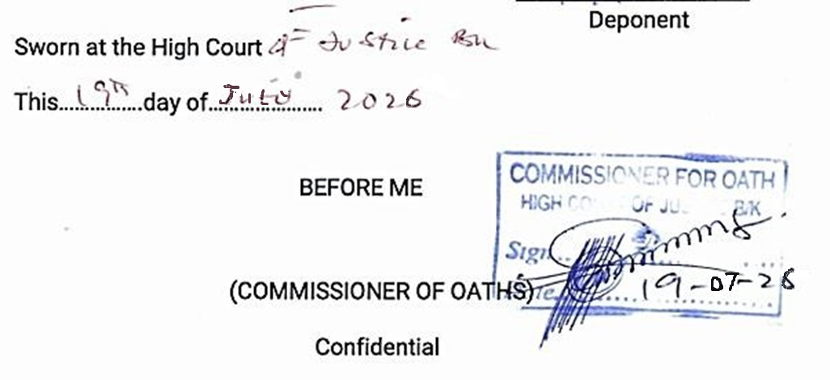
----------------------- -------------------
KOFAR FADA AZARE

------------------------------------------
------------------------------------------
------------------------------------------
THE MANAGER,
PREMIUM PENSION LIMITED,
KEBBI BRANCH.
DEAR SIR,
PAYMENT OF 25% EQUITY FOR RESIDENTIAL MORTGAGE
I wish to access twenty-five percent of my retirement savings account balance for the purpose of acquiring a house. I will be grateful if you can make the process seamless.
Thank You.

Yours Faithfully,
NAME: MUKTAR IBRAHIM
PIN: PEN100653061410
PHONE NO: 08034275466
SIGNATURE:
DATE: 21/05/2026

Appendix 2
KOFAR FADA AZARE

-------------------------------------------------

- --_

Confidential
The Managing Director
Premium Pension Limited
4, Awgu Close, Off Faskari Crescent,
Area 3 Garki, Abuja
Dear Sir,

CONSENT TO PAY FOR EQUITY CONTRIBUTION TOWARDS RESIDENTIAL MORTGAGE FROM MY RSA
Tick if you had accessed RSA due to Temporary loss of Employment. Tick if this is a Joint Application.
I do hereby declare that I had been properly enlightened of the impact of accessing equity contribution for Residential Mortgage on my Retirement Savings Account (RSA) Balance.
Furthermore, I consent that application of a percentage of my RSA balance for equity contribution for residential mortgage shall be once, in line with the clause 3.4 of the Guidelines on Accessing the Retirement Savings Account balance towards payment of Equity Contribution for Residential Mortgage by RSA Holders.
Notwithstanding the above, I hereby authorize PFA to pay 25% of my RSA balance as at the date of submission of my request, as equity contribution for residential mortgage, irrespective of the percentage of equity contribution required by the Mortgage Lender. However, where the value of 25% of my RSA balance is higher than the equity contribution required by the Mortgage Lender, I shall only access an amount equivalent to the equity contribution required by the Mortgage Lender. Conversely, where the value of 25% of the RSA is lower than the equity contribution required by the Mortgage Lender, I shall deposit the difference with the Mortgage Lender before the release of 25% of my RSA balance by my PFA.
I have also been informed of the options to include my Voluntary Contributions contingent portion, NSITF and Pre-Scheme Contribution to augment the equity contribution in the event that 25% of my RSA balance is insufficient to pay the 25% equity contribution to the Mortgage Lender. Tick the box(es) below if you want to include any of the above options.
VC Contingent  NSITF  Pre-Scheme Contribution Thank you for your co-operation.
Yours faithfully,
NAME: MUKTAR IBRAHIM
PIN: PEN100653061410
PHONE NO: 08034275466
SIGNATURE:
DATE: 21/05/2026

